Nguyễn Thanh Xuân Tùng
ITITIU16144

Introduction to AI
Lab 03

1) Read data CustomerChurn
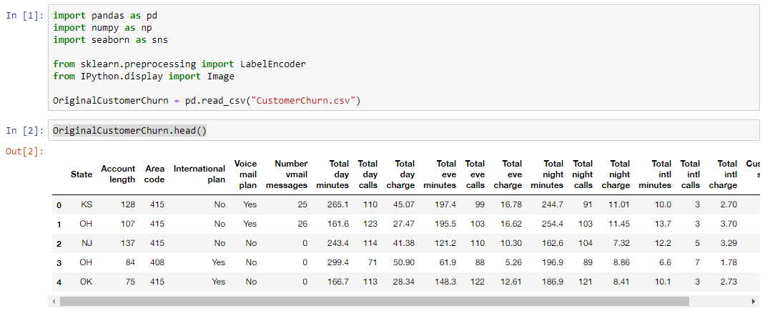

2) Learning Process with Encoding for ‘State’, ‘International plan’, ‘voice mail plan’
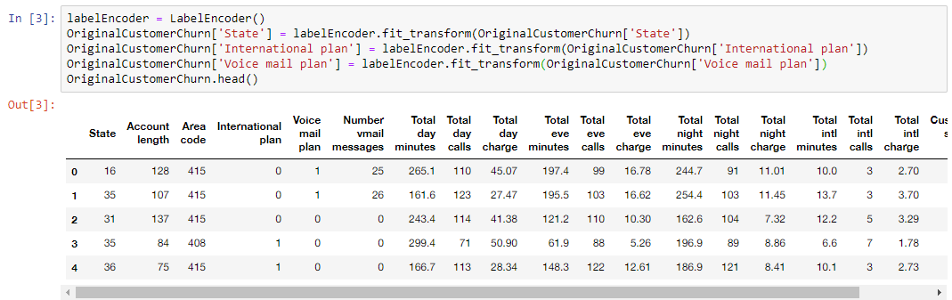

3) Call SplitDataFrameToTrainAndTest with arguments: DataFrame is data_encoder, TrainDataRate=0.6 and TargetAtt=’Churn’
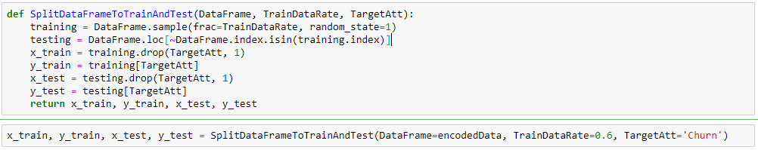

4) Define the function of Naïve Bayes Learning and Testing
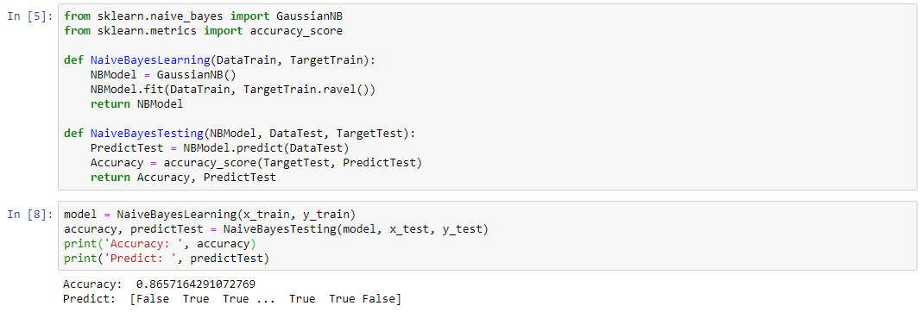

5) Define the function of Decision Tree Learning and Testing
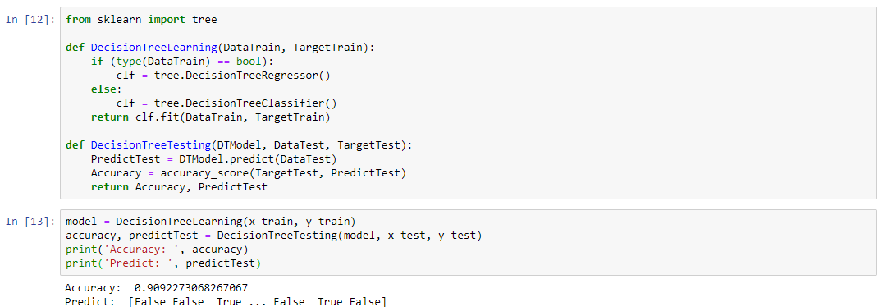

6) Draw the Decision Tree
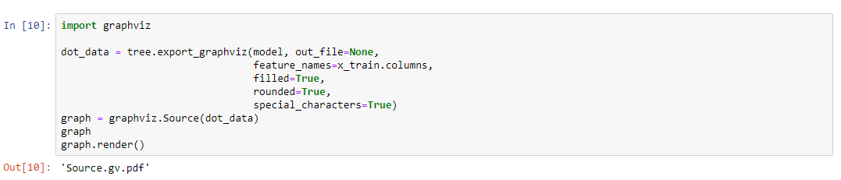
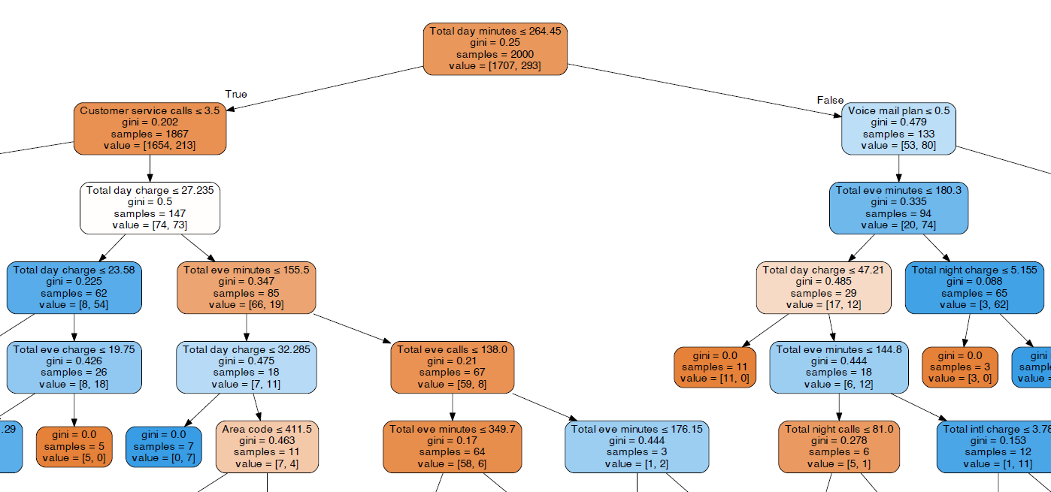
7) Function DetectOutlierByIQR
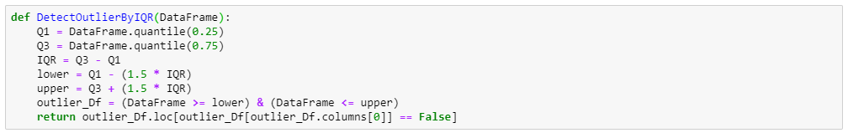
8) Function DetectOutlierByLOF
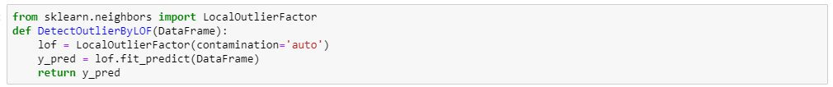
9) Function RemoveRowFromDataFrame
10) Get List of outliers
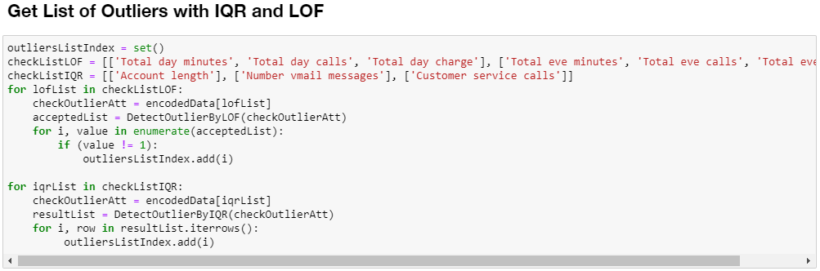

11) Get Mined Encoded Data
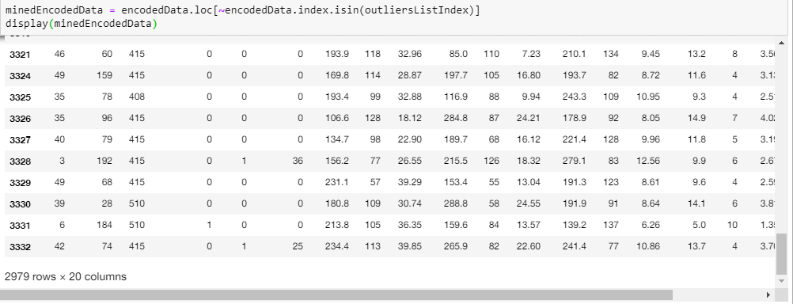

12) Try to Train and Test again with Mined Encoded Data
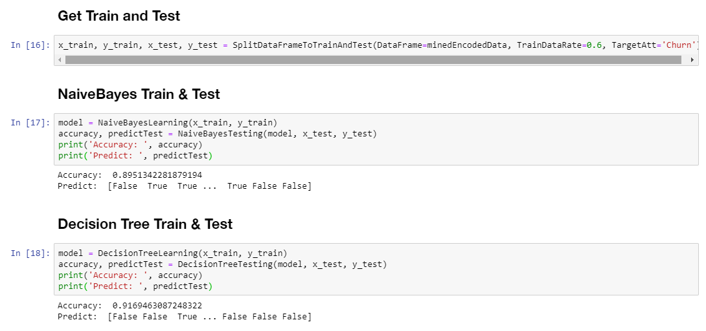

13) Graph the Decision Tree
